- Explain about Boundary Value Analysis & Equivalence Parition
Boundary Value Analysis
Focuses on testing values at the edges or boundaries of input ranges where defects are most likely to occur.
Verifying the limits like min, max, just below, and just above boundaries.
Use case:
Job Portal : Where applicants were eligible for applying age ranges between 18-45
- If the applicant is below <18 he’s not applicable
- If the applicant is above >45 he’s not applicable

  - Equivalence Partition Technique.
Divides input data into valid and invalid Scenarios where test cases are derived from each Functionality.
If age must be 18-45, valid class = 18–45, invalid classes = <18 and >45.
→ Test with one value from each: 19, 16, 61,45

- Explain about Software Requirement Types ?
- Functional Requirements – Login page , Cart , Homepage Adding value to the user.
- Non- Functional Requirements – Performance , Security and Usability.
- Domain Specify Requirements – Banking specific (Transactions, KYC , Check balance)
E-commerce – Homepage , Products page , Login page etc,

- Explain about State Transition Testing with State Diagram and Tabular Column examples.
State Transition Testing checks system behaviour based on state changes due to inputs or events.
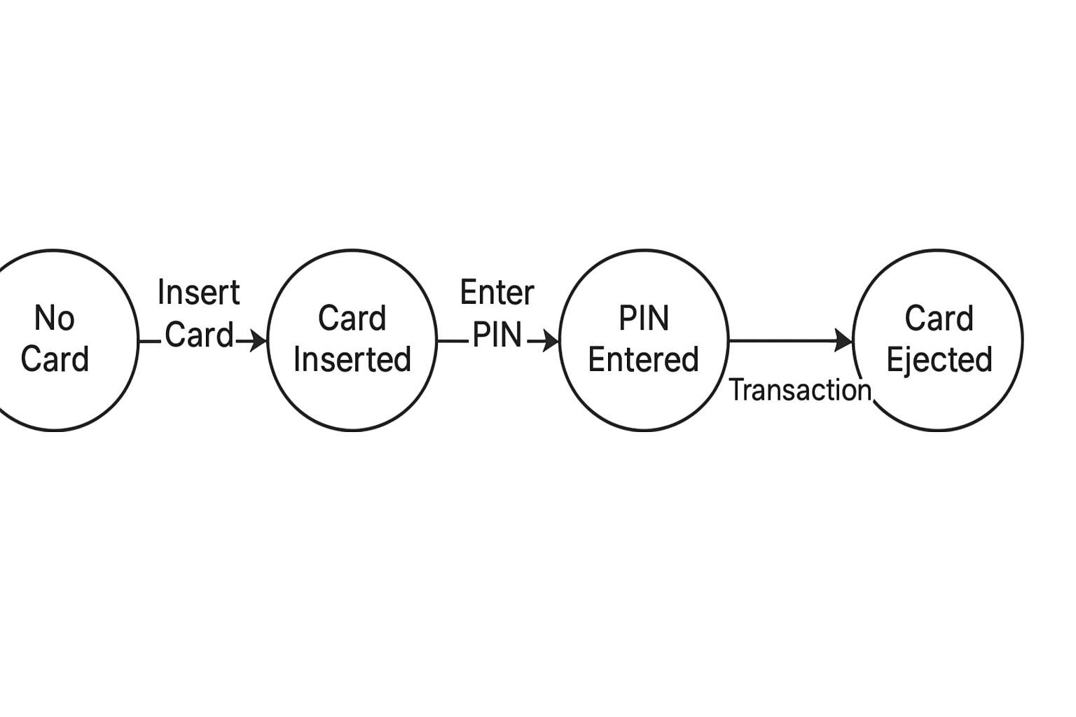
Current State | Input | Next State | Output
No Card | Insert Card | Card Inserted | Prompt for PIN
Card Inserted | Enter Correct PIN | Transaction | Access Granted
Card Inserted | Enter Wrong Pin | Transaction failed | Access not Granted.

- What is Use case Testing? Give some examples
Use Case Testing validates end-to-end business scenarios from a user’s perspective.
It ensures the system behaves as expected for real user actions.
Each use case describes actor, steps, and expected outcome.
Examples:
- ATM – Withdraw cash successfully.
- E-commerce – Add to cart → Checkout → Payment → Order confirmation.

